Hi Everyone,
Please have a look at the Oxford Owl website as there are lots of activities for Reading, English and Maths, including free access to a number of ebooks. This is great to keep up with reading at home and the children will love the fun and engaging activities.
The books are organised into age groups for the children to access which helps you to pick the right level for your child.
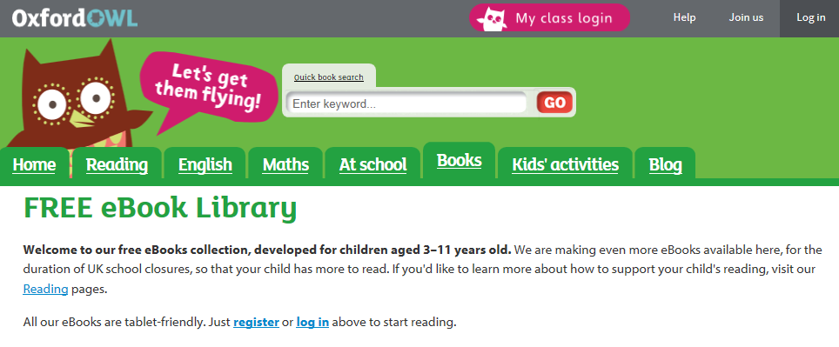
Another great free resource is ‘Teach Your Monster to Read’ by Usborne Books.
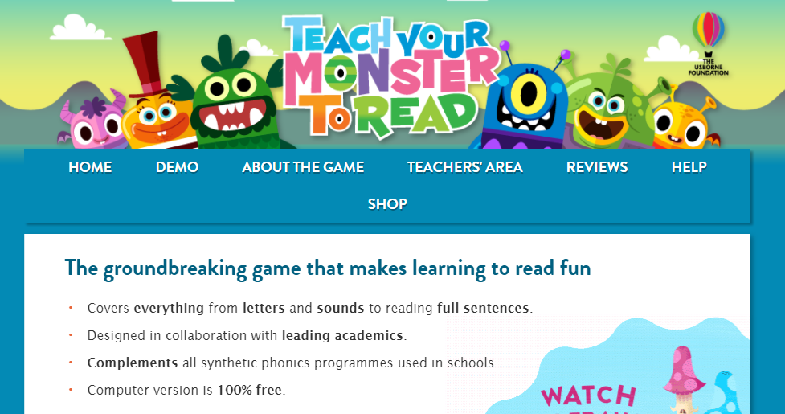
I have also informed parents of the thirty day trial which is offered at the moment from Reading Eggs.
Should you need any further support please contact me at cfhomework@sthelens.org.uk
Best wishes Miss Farrell

