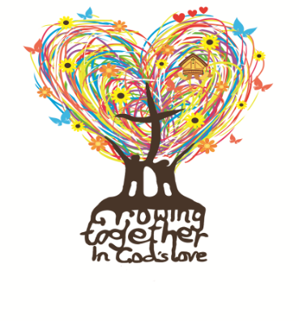

St Thomas of Canterbury
RC Primary School

Supporting your child with phonics
in Reception

Set 1 and 2 Speed Sounds
The information in this booklet will explain the phonics teaching that your child will receive daily at school during their time in Reception.

If you need clarification or would like to know more about our phonics teaching, please make an appointment to speak to myself and I will do my best to answer your questions.

Thank you for your continued support.
Miss C. Farrell

In Reception, your child explores the sounds below by sight. They also develop skills of how to blend them together to read words e.g. c-a-t cat.

What are speed sounds?
In Read Write Inc. phonics, the individual sounds are called ‘speed sounds’. This is because we want your child to read them effortlessly, ‘at speed’.
We encourage the children to avoid saying ‘uh’ after each sound as we need to say sounds in their purest form to support our phonic development. (‘mmmh’ not ‘muh’ ’m’)
**Please note that although we do sing the alphabet song in class, we do not refer to letters by their name (e.g. ‘m’ as ‘em’). It is very important that children learn the letters that represent the different sounds. **

Speed Sounds Set 1
m, a, s, d, t, i, n, p, g, o, c, k, u, b, f, e, l, h, sh, r, j, v, y, w, th, z, ch, qu, x, ng, nk

Speed Sounds Set 2
When each child is ready, they will progress onto learning their Set 2 sounds. There are 12 Set 2 ‘speed sounds’ that are made up of two or three letters which represent just one sound, e.g. ay as in play and igh as in high. It is important that your child does not pronounce these as 2 or 3 separate sounds. When they see the ‘speed sound’ letters together in a word, they must say just one sound for these letters.

When your child learns Set 2 sounds in school, they will learn:
- the letters that represent a speed sound e.g. ay
- a simple picture prompt linked to the ‘speed sound’
- a short phrase to say e.g. may I play

Set 2 Sounds
ay: may I play
ee: what can you see
igh: fly high
ow: blow the snow
oo: poo at the zoo
oo: look at a book
ar: start the car
or: shut the door
air: that’s not fair
ir: whirl and twirl
ou: shout it out
oy: toy for a boy

Green words
Every speed sound has a list of green words linked to it, so your child can ‘sound out’ and ‘sound blend’ words containing the new speed sound they have just learnt, for example:
s-p-r-ay spray b-oo-k book
t-oy toy f-oo-t foot
g-ir-l girl
h-or-se horse

The dots under each letter remind the children to sound each individual sound first, then blend them to say the word.

Red words
They can be thought of as the tricky words because you can’t ‘sound them out’ to read them. These words are common words that appear often in reading and need to be learnt by sight. We practise these words as part of our daily phonic session.
the a do to is his are was went be he
she I me we by my put push pull full so
you with said look wanted

Year 1 Red words
All ball tall today of has your here why when what where school who house our love her do some come little have Mrs Mr give
want

