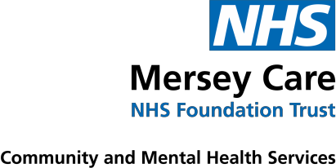
St Helens Immunisation Team
Ashtons Green Children’s Centre
Ashtons Green Drive
WA9 2AP
Telephone: 01744 624353
Flu Campaign 2021

Dear Parent/Guardian,

Your child’s annual flu vaccination is due from September onwards

This vaccination is recommended to help protect your child against flu. Flu can be an unpleasant illness and sometimes causes serious complications. Vaccinating your child will also help protect more vulnerable family and friends by preventing the spread of flu.

The vaccination is free and is a quick and simple spray up the nose. Even if your child had the vaccine last year, it is recommended that they have the flu vaccine again this year.

While COVID-19 is in circulation, the Healthcare team and school will follow guidelines to ensure children are safe when being offered the vaccine.

For further information about the vaccination programme please click on this link www.nhs.uk/child-flu as it provides details about the small number of children for whom the nasal vaccine is not appropriate.

Please follow the link emailed to you from school to complete your childs consent form even if you do not want your child to receive their flu vaccination.

If you have any queries or are unable to complete the online consent form, please contact the Immunisation Team: 01744 624353.

Yours faithfully,

Immunisation Team

If your child becomes wheezy or has their asthma medication increased after you return this form, or attends the GP for their flu vaccination please contact the Immunisation Team: 01744 624353
Chairman Beatrice Fraenkel Chief Executive Joe Rafferty, CBE

